SQL- Library Management System

Developed By: Mohammed Fasil P (DSML26)

Date : 26-09-2024

Create a database named library and following TABLES in the database:

*/

*create database library;*

*use library;*

/*

Create TABLE in the database:

**1. Branch**

*/

*create table branch(*

*Branch_no int auto_increment PRIMARY KEY,*

*Manager_Id int,*

*Branch_address varchar(250),*

*Contact_no char(10));*

*INSERT INTO branch (Branch_no, Manager_Id, Branch_address, Contact_no)*

*VALUES (1,101,'Mongam','6576436786'),*

*(2,123,'Valluvambram','5765767654'),*

*(3,654,'Thrippanchi','273t767574'),*

*(4,323,'Edavanna','2456743344'),*

*(5,222,'Areekkode','3242345323');*

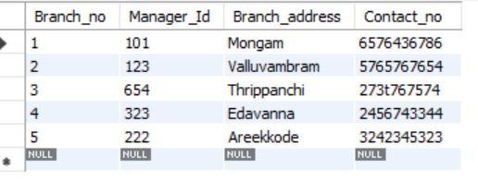

/*

Create TABLE in the database:

**2. Employee**

*/

*create table employee(*

*Emp_Id int PRIMARY KEY auto_increment,*

*Emp_name varchar(50),*

*Position varchar(50),*

*Salary decimal(10,2),*

*Branch_no int,*

*FOREIGN KEY(Branch_no) references library.branch(Branch_no)*

*);*

*INSERT INTO employee (Emp_Id, Emp_name, Position, Salary, Branch_no)*

*VALUES (6,'Akib sadin','Manager',65000.00,1),*

*(7,'Lami p','Accountant',25000.00,3),*

*(8,'Minha','Security',10000.00,3),*

*(9,'Favas p','Accountant',20000.00,1),*

*(10,'Fayis p','Accountant',55000.00,5),*

*(11,'Unni','Security',12000.00,3),*

*(12,'Keshav','manager',52000.00,3),*

*(13,'Anu','Sales man',18000.00,3),*

*(14,'Jafer','Sales man',14000.00,3);*

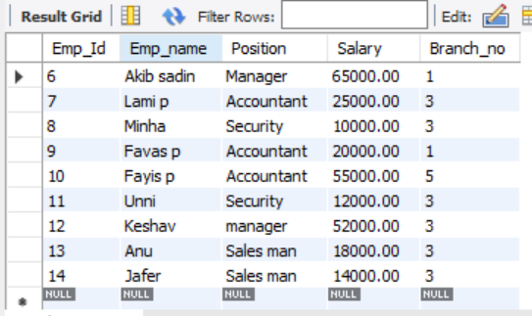

/*

Create TABLE in the database:

**3. Books**

*/

*create table books(*

*ISBN int PRIMARY KEY auto_increment,*

*Book_title varchar(50),*

*Category varchar(20),*

*Rental_Price decimal(5,2),*

*Status char(5),*

*Author varchar(50),*

*Publisher varchar(50)*

*);*

*INSERT INTO books (ISBN, Book_title, Category, Rental_Price, Status, Author, Publisher)*

*VALUES (1,'Making India Awesome','Categ1',25.00,'yes','Chetan Bhagat','fasil'),*

*(2,'One Indian Girl history','Categ2',15.00,'yes','Chetan Bhagat','fasil'),*

*(3,'A Million Mutinies Now','Categ2',30.00,'yes','V.S. Naipaul','savad'),*

*(4,'A Brush with Life','Categ1',20.00,'yes','Satish Gujral','savad'),*

*(5,'Half Girlfriend','Categ1',49.00,'no','Chetan Bhagat','fasil'),*

(6,'History of Mahathma gandhi','categ4',34.00,'no','Bh.ayartas','binu');

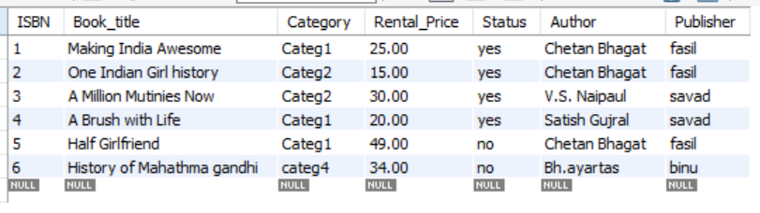

/*

Create TABLE in the database:

**4. Customer**

*/

*create table Customer(*

*Customer_Id int PRIMARY KEY auto_increment,*

*Customer_name varchar(50),*

*Customer_address varchar(200),*

*Reg_date date*

*);*

*INSERT INTO customer (Customer_Id, Customer_name, Customer_address, Reg_date)*

*VALUES (1,'Jan maunu','calicut, kerala','2023-02-03'),*

*(2,'Abhi ashok','checnnai,thamilnadu','2023-02-03'),*

*(3,'Kasim mansoor','malappuram,kerala','2021-03-11'),*

*(4,'Keyath manu','kannur, kerala','2023-02-05'),*

*(5,'Minu ava','kochi kerala','2021-03-11');*

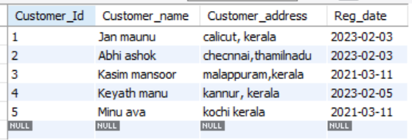

/*

Create TABLE in the database:

5. IssueStatus

*/

*create table IssueStatus(*

*Issue_Id int PRIMARY KEY auto_increment,*

*Issued_cust_id int,*

*Issued_book_name varchar(50),*

*Issue_date date,*

*Isbn_book int,*

*FOREIGN KEY(Issued_cust_id) references library.Customer(customer_id),*

*FOREIGN KEY(Isbn_book) references library.books(ISBN)*

*);*

*INSERT INTO issuestatus (Issue_Id, Issued_cust_id, Issued_book_name, Issue_date, Isbn_book)*

*VALUES (1,1,'One Indian Girl','2022-10-12',2),*

*(2,2,'A Brush with Life','2023-06-02',4),*

*(3,4,'A Million Mutinies Now','2022-10-20',3),*

*(4,5,'A Million Mutinies Now','2022-10-22',3),*

*(5,2,'One Indian Girl','2022-10-21',2);*

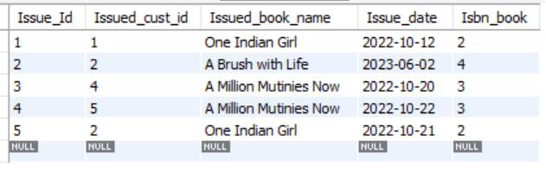

/*

Create TABLE in the database:

**6. ReturnStatus**

*/

*create table ReturnStatus(*

*Return_Id int PRIMARY KEY auto_increment,*

*Return_cust varchar(50),*

*Return_book_name varchar(50),*

*Return_date date,*

*Isbn_book2 int,*

*FOREIGN KEY(Isbn_book2) references library.books(ISBN)*

*);*

*INSERT INTO returnstatus (Return_Id, Return_cust, Return_book_name, Return_date, Isbn_book2)*

*VALUES (1,'1','One Indian Girl','2022-10-12',2),*

*(2,'5','A Million Mutinies Now','2022-10-12',3),*

*(3,'2','One Indian Girl','2022-10-12',2);*

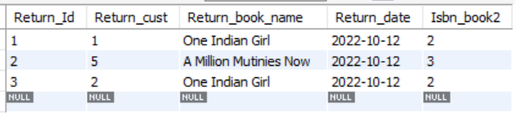

/*

1. Retrieve the book title, category, and rental price of all available books.

*/

*select Book_title,Category,Rental_Price from library.books*

*where Status='yes';*

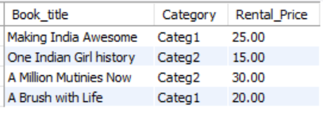

/*

2. List the employee names and their respective salaries in descending order of salary.

*/

*select Emp_name,Salary from library.employee*

*order by Salary desc;*

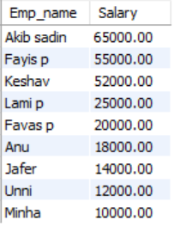

/*

3. Retrieve the book titles and the corresponding customers who have issued those books.

*/

*select i.Issue_Id,b.Book_title,c.Customer_name from library.issuestatus as i left join library.books as b on i.Isbn_book=b.ISBN*

*left join library.customer as c on i.Issued_cust_id=c.Customer_Id;*

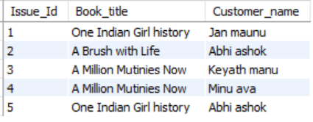

/*

4. Display the total count of books in each category.

*/

*select Category,count(*) as Total_count from library.books*

*group by Category;*

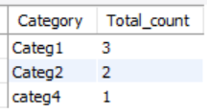

/*

5. Retrieve the employee names and their positions for the employees whose salaries are above Rs.50,000.

*/

*select Emp_name from library.employee*

*where Salary>50000;*

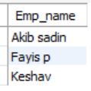

/*

6. List the customer names who registered before 2022-01-01 and have not issued any books yet.

*/

*select Customer_name from library.customer*

*where Reg_date<date('2022-01-01') and Customer_Id not in(select Issued_cust_id from library.issuestatus);*

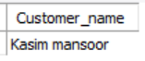

/*

7. Display the branch numbers and the total count of employees in each branch.

*/

*select Branch_no,count(Branch_no) as Total_empoyees from library.employee*

*group by Branch_no;*

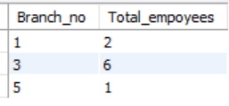

/*

8. Display the names of customers who have issued books in the month of June 2023.

*/

*select Customer_name from library.customer*

*where Customer_Id in (*

*select Issued_cust_id from library.issuestatus*

*where year(Issue_date)=2023 and month(Issue_date)=6);*



/*

9. Retrieve book_title from book table containing history.

*/

*select Book_title from library.books*

*where Book_title like '%history%';*

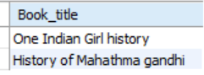

/*

10.Retrieve the branch numbers along with the count of employees for branches having more than 5 employees

*/

*select Branch_no,count(Branch_no) as Count_of_employess from library.employee group by Branch_no*

*having count(Branch_no)>5;*

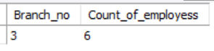

/*

11. Retrieve the names of employees who manage branches and their respective branch addresses.

*/

*select e.Emp_name,b.Branch_address from library.employee as e left join library.branch as b on e.Branch_no=b.Branch_no;*

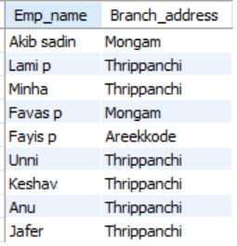

/*

12. Display the names of customers who have issued books with a rental price higher than Rs. 25.

*/

*select Customer_name from library.customer where Customer_Id in (*

*select Issued_cust_id from library.issuestatus where Isbn_book in(*

*select ISBN from library.books where Rental_Price>25));*

